Building an Online Auction Website*

- Three-tier Web application
- Dynamic generation of XML documents
- Extracting data from XML documents
- Create a user interface

An online auction is the epitome of a complex real-time interactive application – not to mention being the hottest business-to-consumer (B2C) business model on the Web! This document describes a realistic Auction Demo that shows that even complex applications can be based on straightforward use of the three-tier Web architecture.

The Auction Demo is a three-tier Web application that simulates an online auction using technologies that have been available since Internet Explore 5.01. It allows you to (1) view the items available for auction, (2) place bids on those items, and (3) monitor the bids placed by fellow bidders.

Like other three-tier Web applications, the Auction Demo has (1) data sources on the back end, (2) a user interface on the client, and (3) a Web server in the middle. We will see how it was developed, using three permanent Web pages:

UserInterface.htm. This page uses Dynamic HTML (DHTML) to allow the Web browser to present the auction information to the user. It contains scripts that collect or update data on the middle tier by requesting Active Server Page (ASP)

Auction.asp. This page is an ASP file. When userInterface.htm requests this page, the scripts in it are executed on the server. The scripts generate auction.xml, an XML document that contains the latest auction data, which is delivered to the client.

makebid.asp. This page is requested by userInterface.htm .when the user wants to make a bid. It is executed on the middle tier, causing the data source to be updated with the new bid information.

The user interface (UI) for the Auction Demo is shown in Figure 1. It is the rendition of the userInterface.htm Dynamic HTML page, which is downloaded to the client when the user clicks on a link to the auction.

That page has scripts within it that handle all the client-side activity. That includes requesting data from the middle tier in order to display the most current values of the items and bids. We'll see later how the UI page does its thing, but first let's look at how the middle tier collects and transmits the data. It does so by packaging the data as XML documents.
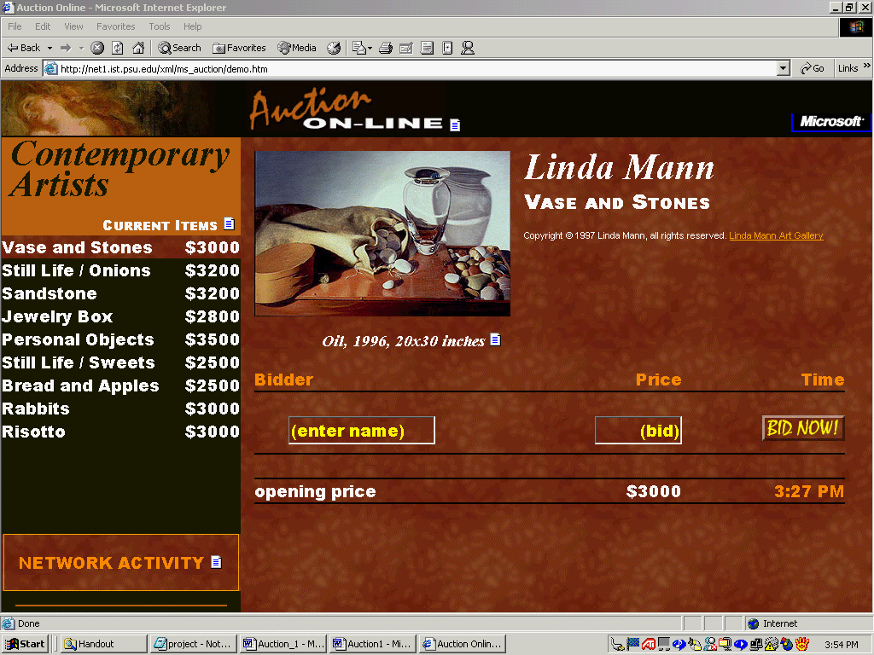

1. Getting Data From the Middle Tier

The role of the middle tier in a Web application is to gather information from data sources and deliver it in a consistent manner to clients. In the Auction Demo we start with a single data source, an ODBC-compliant database. (Later we'll see how multiple data sources of different kinds can be accessed.)

The "Auction" database used for the Auction Demo is a relational database with two tables, an "Item" table and a "Bids" table. The "Item" table contains data about each of the items up for auction. It is shown in Figure 2 1.

For the sake of clarity, we'll just cover the "Item" table in this chapter (the "Bids" are handled similarly). You can see the full demo in the MS_Auction folder on the course ftp site (ID: IST420). We want to deliver the data in that table in the form of an XML document, so the client's user interface page won't have to know anything about the actual data source.

1.1. Defining the XML document structure

The key to creating useful XML documents is the proper structuring of the data. For the Auction Demo, that means deciding how a record in the "Item" table will be represented as an ITEM element in XML. There is a straightforward mapping, shown in the data-less element in Example 1.

Title | Artist | Dimensions | Materials | Year
Vase and Stones | Linda Mann | 20x30 inches | Oil | 1996
Still Life / Onions | Linda Mann | 20x30 inches | Oil | 1997
Sandstone | Linda Mann | 20x30 inches | Oil | 1995
Jewelry Box | Linda Mann | 20x30 inches | Oil | 1994
Personal Objects | Linda Mann | 20x30 inches | Oil | 1995
Still Life / Sweets | Linda Mann | 20x30 inches | Oil | 1994
Bread and Apples | Linda Mann | 20x30 inches | Oil | 1995
Rabbits | Linda Mann | 20x30 inches | Oil | 1996
Risotto | Linda Mann | 20x30 inches | Oil | 1995

Figure 2: The Auction Demo Item Table

Example 1. Template for an ITEM element

<ITEM>
<TITLE></TITLE>
<ARTIST></ARTIST>
<DIMENSIONS></DIMENSIONS>
<MATERIALS></MATERIALS>
<YEAR></YEAR>
</ITEM>

For each field in the "Item" table, there is a corresponding subelement of the ITEM element. To generate XML documents with these ITEM elements, the Auction Demo uses ASP files.

1.2. Using ASP files to generate XML documents

XML can be generated on the middle tier using Active Server Pages. ASP offers an environment in which Web authors can create documents dynamically by intermixing markup languages with in-line scripts. The scripts can be written in a variety of scripting languages, including JScript and VBScript, and can invoke server-side components to access databases, execute applications, and process information.

When a browser requests an ASP file, it is first processed by the server, which delivers a generated Web page containing standard markup.

In an ASP file, commands and scripts are delimited by "<%" and "%>". Everything not so delimited is markup or data that will appear in the generated page. For example, consider the trivial ASP file in Example 2.

Example 2. Sample ASP file

<%@LANGUAGE = VBScript %>
<%DIM Total = 2%>
<AMOUNT><%=Total%></AMOUNT>

The file, after establishing that the scripting language is VBScript, creates the variable "Total" with the value "2". The following line generates an XML AMOUNT element whose content is generated by executing the small script, which in this case retrieves the value of "Total".

When the browser requests this file, it will actually receive the XML document that is generated from the file, as shown in Example 3.

Example 3. XML document generated by sample ASP file

<AMOUNT> 2 </AMOUNT>

Note that the ASP syntax (<%. . . %>) does not cause an XML parsing error. That is because the ASP file is not itself an XML document. The ASP file is processed on the server and only the generated XML document is returned to the client.

In the case of the Auction Demo, the file auction.asp is used to access the "Auction" database and generate XML containing the data within the "Item" and "Bids" tables. The ability to generate XML on the middle tier makes it possible to provide the Web application with content that can be manipulated on the client and refreshed without having to refresh the entire user interface.

In Example 4, auction.asp begins like the ASP file in Example 2, by declaring the scripting language. The next two lines are the XML declaration and the start-tag of the root element (AUCTIONBLOCK) of the XML document to be generated, which we will call "auction.xml".

Example 4. Start of auction.asp

<%@ LANGUAGE = VBScript %>
<?xml version=’1.0” ?>
<AUCTIONBLOCK>

Next, a connection to the "Auction" database is established and that connection is opened:

Example 5. Connecting to the database

<%
Set Conn = Server.CreateObject (“ADODB.Connection”)
Conn.Open “Auction”,”Auction”,”Auction”
%>

A "record set" variable (ItemRS) is now established to contain each record of the "Item" table as it is accessed, and a "Do While" loop is begun to perform the access.

Example 6. Preparing to access the "Item" records

<%
Set ItemRS = Conn.Execute (“select * from item”)
Do While Not ItemRS.EOF
%>

Next, the template in Example 1 is used to create the XML ITEM element that will be generated. Just as in Example 2, a small script is inserted as the content of each subelement of ITEM within auction.asp. In this case, the script extracts the corresponding field's data from the record set.

Example 7. Markup and scripts to generate an ITEM element

<ITEM>
<TITLE><%=ItemRS(“Title”) %></TITLE>
<ARTIST><%=ItemRS(“Artist”) %></ARTIST>
<DIMENSIONS><%=ItemRS(“Dimensions”) %></DIMENSIONS>
<MATERIALS<<%=ItemRS(“Materials”) %></MATERIALS>
<YEAR><%=ItemRS(“Year”) %></YEAR>
</ITEM>

After an ITEM element is generated, the script moves to the next record in the record set. The loop is then repeated. Once all of the records have been run through, the root element is ended.

Example 8. Repeating the loop and ending the document

<%
ItemRS.MoveNext
Loop
%>
</AUCTIONBLOCK>

The complete auction.asp file is in Example 9. Example 10 is an abridged version of the XML document (auction.xml) generated by the auction.asp file in Example 8-9.

1.3. Generating XML from multiple databases

One powerful reason to generate XML documents on the middle tier is that they can contain data that is sourced from multiple independent databases. The technique is similar to what we've already seen. The only difference is that multiple database connections are made instead of one.

The ASP file in Example 11 does just this, generating a single XML document with data from the databases "Gallery 1" and "Gallery2".

Example 9. The complete auction.asp file

<%@ LANGUAGE = VBScript %>
<?xml version="1.0"?>
<AUCTIONBLOCK>
<%
Set Conn = Server.CreateObject("ADODB.Connection") Conn. Open "Auction", "Auction", "Auction"
Set ItemRS = Conn.Execute("select * from item")
Do While Not ItemRS.EOF
%>
<ITEM>
<TITLE><%=ItemRS("Title")%></TITLE>
<ARTIST><%=ItemRS ("Artist") %></ARTIST> <DIMENSIONS><%=ItemRS("Dimensions")%></DIMENSIONS>
<MATERIALS><%=ItemRS("Materials")%></MATERIALS>
<YEAR><%=ItemRS("Year")%></YEAR>
</ITEM>
<%
ItemRS.MoveNext
Loop
%>
</AUCTIONBLOCK>

Example 10. Abridged auction.xml document generated by auction.asp

<?xml version="l.0"?>
<AUCTIONBLOCK>
<ITEM>
<TITLE>Vase and Stones</TITLE>
<ARTIST>Linda Mann</ARTIST>
<DIMENSIONS>20 X 30 inches</DIMENSIONS>
<MATERIALS>Oil</MATERIALS>
<YEAR>1996</YEAR>
</ITEM>
<ITEM>
...
</ITEM>
...
</AUCTIONBLOCK>

The XML generated by the ASP file in Example 11 looks structurally just like Example 10, an AUCTIONBLOCK element with multiple ITEM children. However, the data content originates from two different data sources.

Example 11. Generating one XML document from two databases
<%@ LANGUAGE = VBScript %>
<?xml version="l.0"?>
<AUCTIONBLOCK>
<%
'Connect to the Galleryl database data source
Set Conn = Server.CreateObject("ADODB.Connection") Conn. Open "Galleryl","Galleryl","Galleryl"
Set ItemRS = Conn.Execute("select * from item")
Do While Not ItemRS.EOF
%>
<ITEM>
<TITLE><%=ItemRS ("Title") %></TITLE>
<ARTIST><%=ItemRS (" Artist") %></ARTIST> <DIMENSIONS><%=ItemRS("Dimensions")%></DIMENSIONS> <MATERIALS><%=ItemRS ("Materials") %></MATERIALS>
<YEAR><%=ItemRS ("Year") %></YEAR>
</ITEM>
<%
ItemRS.MoveNext
Loop
'Connect to the Gallery2 database data source
Set Conn = Server.CreateObject("ADODB.Connection")
Conn.Open "Gallery2" , "Gallery2" , "Gallery2"
Set ItemRS = Conn.Execute("select * from item")
Do While Not ItemRS.EOF
%>
<ITEM>
<TITLE><%=ItemRS("Title")%></TITLE>
<ARTIST><%=ItemRS ("Artist") %></ARTIST> <DIMENSIONS><%=ItemRS("Size")%></DIMENSIONS> <MATERIALS><%=ItemRS("Medium")%></MATERIALS>
<YEAR><%=ItemRS ("Date") %></YEAR>
</ITEM>
<%
ItemRS.MoveNext
Loop
%>
</AUCTIONBLOCK>

Also notice that, for the DIMENSIONS, MATERIALS, and YEAR elements, the source fields in the "Gallery2" database are actually labeled differently from the corresponding fields in "Gallery 1." One benefit of consolidating the data on the middle tier is that the semantics can be identified consistently, and therefore made more easily accessible.

1.4. Generating XML from both databases and XML data sources

The middle tier can source data of different kinds, not just databases. In Example 12, the ASP file, as in previous examples, first accesses data from "Gallery 1", an ODBC compliant database. However, it' then adds data from "Gallery 3", a source of XML documents.

The Gallery 3 XML document is processed by the MSXML parser (details below), which allows access to the document's data content. Note that there is no way - and no need - to tell whether Gallery 3 is a persistent document, or was generated by another middle-tier application.

2. Building the User Interface

The user interface is critical to the success of any application. It must allow the user to interact with the application in an efficient and straightforward manner. The user interface for the Auction Demo was built using DHTML.

DHTML is a set of features introduced in Internet Explorer 4.0 for creating interactive and visually interesting Web pages. It is based on existing HTML standards and is designed to work well with applications, ActiveX controls, and other embedded objects.

With DHTML a developer can create a robust and efficient UI without additional support from applications or embedded controls, or even return trips to the server. A Dynamic HTML page is self-contained, using styles and scripts to process user input and directly manipulate the HTML markup and other text within the page.

Let's see how userInterface.htm creates the Auction Demo interface by using scripts and the W3C Document Object Model. Two basic techniques are employed: procedural scripts and descriptive binding.

2.1. Using procedural scripts

Internet Explorer 5.01 includes the MSXML parser, which exposes the parsed XML document as a Document Object Model. Once exposed, scripts can access the data content of the XML elements and dynamically insert the data into the user interface.

Example 12. Generating one XML document from a database and another XML document

<%@ LANGUAGE = VBScript %>
<?xml version="l.0"?>

<AUCTIONBLOCK>
<%
'Connect to the Gallery1 database data source
Set Conn = Server.CreateObject("ADODB.Connection")
Conn. Open "Galleryl", "Galleryl", "Galleryl"
Set ItemRS = Conn. Execute ( "select * from item")
Do While Not ItemRS.EOF
%>
<ITEM>
<TITLE><%=ItemRS("Title")%></TITLE>
<ARTIST><%=ItemRS("Artist")%></ARTIST>
<DIMENSIONS><%=IternRS("Dimensions")%></DIMENSIONS>
<MATERIALS><%=ItemRS ("Materials") %></MATERIALS> <YEAR><%=ItemRS("Year")%></YEAR>
</ITEM>
<%
ItemRS.MoveNext
Loop
'Connect to the Gallery3 XML document data source
Set XML = Server.CreateObject("MSXML2.DOMDocument") XML.setProperty("ServerHTTPRequest",true)
XML .load ("http: I Idatasource3 IGallery3.xml")
Set Items = XML.documentElement.childNodes
For I = 0 to Items.length - 1
Set Item = Items.childNodes.item(1)
%>
<ITEM>
<TITLE><%=Item.childNodes.item(0) .text%></TITLE>
<ARTIST><%=Item.childNodes.item(l) .text%></ARTIST>
<DIMENSIONS><%=Item.childNodes.item(2) .text%></DIMENSIONS>
<MATERIALS><%=Item.childNodes.item(3) .text%></MATERIALS>
<YEAR><%=Item.childNodes.item(4) .text%></YEAR>
</ITEM>
<%
Next
%>
</AUCTIONBLOCK>

The userInterface.htm code in Example 13 applies MSXML to auction.xml, the XML document generated by auction.asp. That creates an ActiveX object representing the parsed document.

Example 13. Creating the auction document object

var auction = new ActiveXObject(“MSXML2.DOMDocument”);
auction.load(http://Webserver/auction.asp);

In Example 14, the script next retrieves the root element. It then navigates the tree until it locates the TITLE element within the first ITEM element of auction.xml. The innerText property is used to insert the data content of TITLE into the user interface as the value of the item_title attribute, which appears on a DIV element.

Example 14. Extracting data from the auction document object

var root = auction.documentElement;
var item0 = root.childNodes.item(0);
var title = item0.childNodes.item(0).text;
document.all(“item_title”).innerText = title;
<DIV ID=”item_title”></DIV>

One of the benefits of using procedural scripts to display XML documents is that you can manipulate the data content of an XML element before you display it. For example, if you wanted to display the dimensions of each painting using the metric system, rather than feet and inches, your script could simply convert the content of the DIMENSIONS element from inches to centimeters.

2.2 Using descriptive data binding

The XML Data Source Object (XML DSO) is a declarative alternative to the procedural scripts described in the last section. It enables the data of XML elements to be bound as the content of HTML documents.

Example 15. An XML Data Source Object

<XML ID=”auction” SRC=”auction.asp”></XML>

An XML DSO is shown in Example 15. It is an XML element that assigns the ID "auction" to the data source "auction.asp", which causes auction.xml to be generated on the middle tier. A persistent XML data source could also have been used.

In Example 16, data binding is used to populate the part of the user interface that shows the painting and the caption beneath it. No scripting is needed. Instead, the SPAN elements identify the "auction" DSO as the pointer to the data source and the XML element type name as the DATAFLD to be bound.

Example 16. Data binding with the XML DSO

<TD>
<DIV STYLE="margin-left: 16px;margin-top: 16px;margin-right:l 6px">
<DIV ID=pict></DIV>
<DIV CLASS="details">
<SPAN DATASRC=#auction DATAFLD=MATERIALS></SPAN>,
<SPAN DATASRC=#auction DATAFLD=YEAR></SPAN>,
<SPAN DATASRC=#auction DATAFLD=DIMENSIONS></SPAN>
</DIV>
</DIV>
</TD>

One advantage of displaying XML with the XML DSO is that the XML document is processed asynchronously to the rendering of the page. Therefore, if the inventory of paintings were very large, the initial elements of the XML document could be displayed even before the last elements were processed.

3. Updating the Data Source From the Client

We have seen how userInterface.htm on the client obtained data to display to the user by invoking auction.asp on the middle tier. It can also enable the user to make his own bid by invoking another middle tier page, makebid.asp.

In the Auction Demo, the user bids by overwriting the price and bidder name in the first row of the bid table. A bid therefore consists of the "title" of the item currently displayed, the. "price" of the new bid, and the name of the new "bidder".

These data items must be passed as parameters to makebid.asp, which executes a script to process them and update the database. The script returns to the client a "return message" XML document: a single element containing information about the status of the processing.

The script in userInterface.htm (see Example 17) begins by assigning the title of the current item up for auction to the "title" variable, the value of the "price" text box to the "price" variable, and the value of the "bidder" text box to the "bidder" variable.

It then creates the return message document object, which will state whether makebid.asp successfully updated the database. The three variables are passed as parameters to the ASP file when it is invoked.

Example 17. Sending a new bid to makebid.asp

var title = current_item.childNodes.item(0) .text;
var price = price.value;
var bidder = bidder. value;
var returnMsg = new ActiveXObject("MSXML2.DOMDocument"); returnMsg.load(''http://auction/makebid.asp?title='' +
title + "&price=" + price + "&bidder=" + bidder;

In Example 18, makebid.asp (called by userInterface.htm in Example 17) assigns the values of the parameters "title", "price", and "bidder" to variables with the same names.

The "BidRS" record set object is then created and a connection to the "Auction" database is made. Note that the connection is made for both reading and writing. The "Bids" table is then opened and the new information is added to the record set, after which the connection is closed. The process is much the same as it was for auction.asp, except that the database is written to instead of just being read.

Finally, makebid.asp generates the return message document with the status of the update.

Example 18. The makebid.asp file updates the database

<%@ LANGUAGE = VBScript %>
<%
title = Request.QueryString ("title")
price = Request.QueryString ("price" )
bidder = Request.QueryString ("bidder" )

Set BidRS = Server.CreateObject("ADODB.RecordSet")
connect = "data source=Auction;user id=sa;password=;"
BidRS.CursorType = 2
BidRS.LockType = 3 ‘read/write
BidRS.Open "Bids", connect

BidRS.AddNew BidRS("item") = title
BidRS ("price") = price
BidRS("bidder") = bidder
BidRS.Update
BidRS.Close
%>
<STATUS>OK</STATUS>

4. Conclusion

The entire Auction Demo was built using the methods described above. You can get a head start on building a similar Web application by modifying these scripts to suit your particular requirements.

XML enables Web applications by providing dynamic, accessible content that can be navigated and manipulated on the client. In addition, it enables the updating of content without having to refresh the entire user interface. This ability saves time by reducing round trips to the server for information that already exists on the client.

With XML, users can manage data over the Internet just as they presently do on their local machines. As a result, the Web is made a more interactive and interoperable medium. As the information superhighway has transformed itself into the data superhighway, Web applications similar to the Auction Demo are allowing far better utilization of the vast resources made available by the Web.

Analysis

The Auction Demo clearly illustrates the architecture of a three-tier application. It uses' the middle tier as a transient data aggregator and normalizer. In the next chapter we take a closer look at how data sources can generate XML for use by middle-tier servers.

* Goldfarb, C. F. and Prescod, P., XML Handbook, 4th Edition, Prentice Hall PTR, 2002, pp. 134-150.

